1. Container With Most Water

CODE:

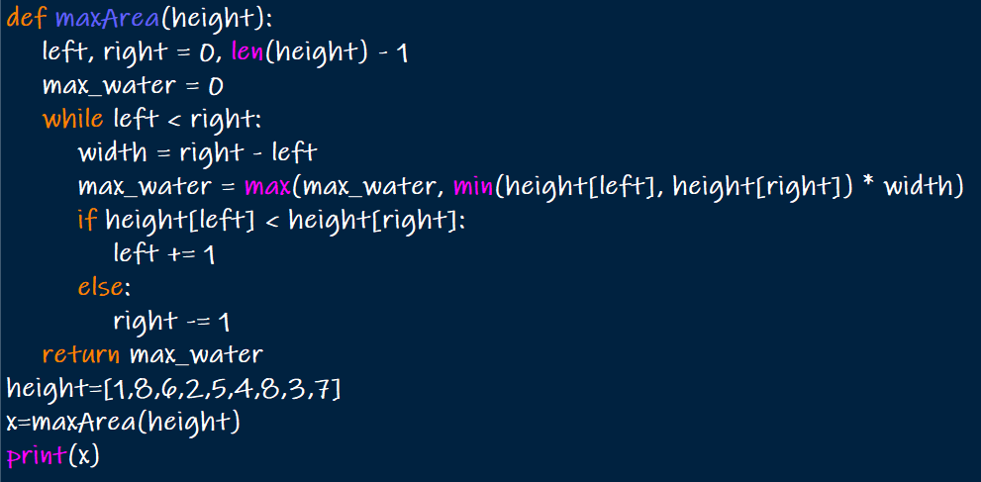

OUTPUT:



1. Integer to Roman

CODE:

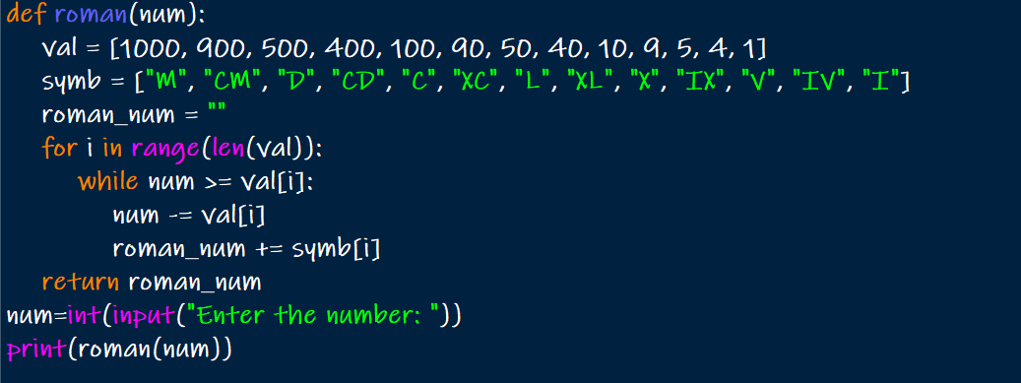

OUTPUT:

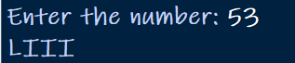

1. Roman to Integer

CODE:

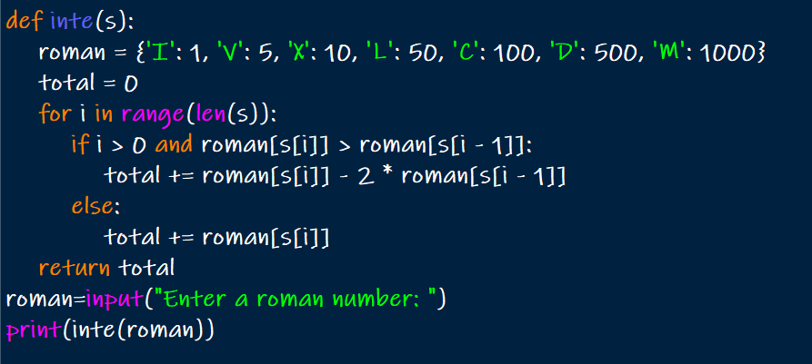

OUTPUT:

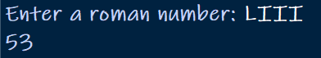

1. Longest Common Prefix

CODE:

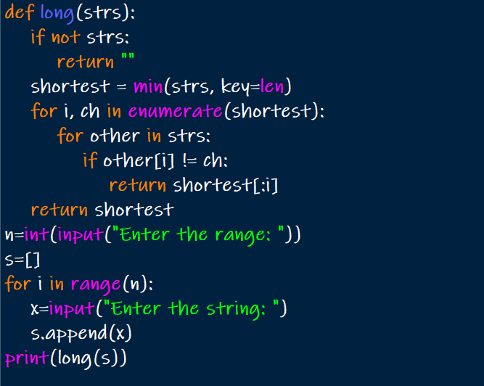

OUTPUT:

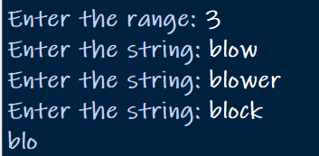

1. 3Sum

CODE:

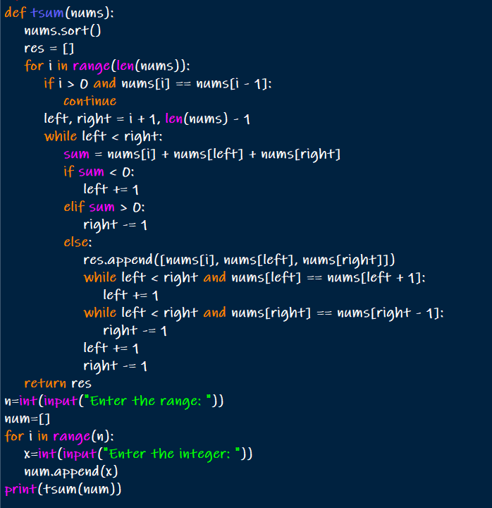

OUTPUT:

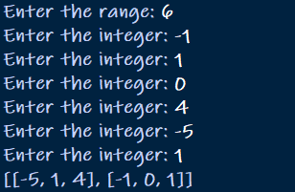

1. 3Sum Closest

CODE:

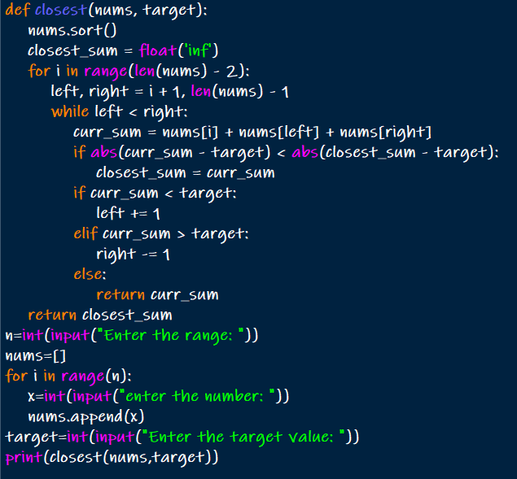

OUTPUT:

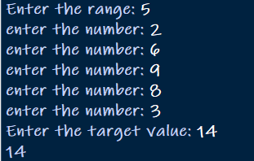

1. Letter Combinations of a Phone Number

CODE:

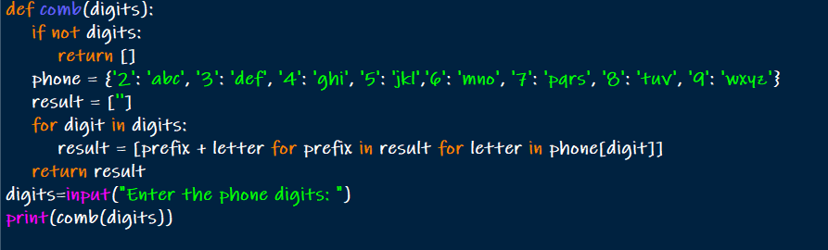

OUTPUT:



1. 4Sum

CODE:

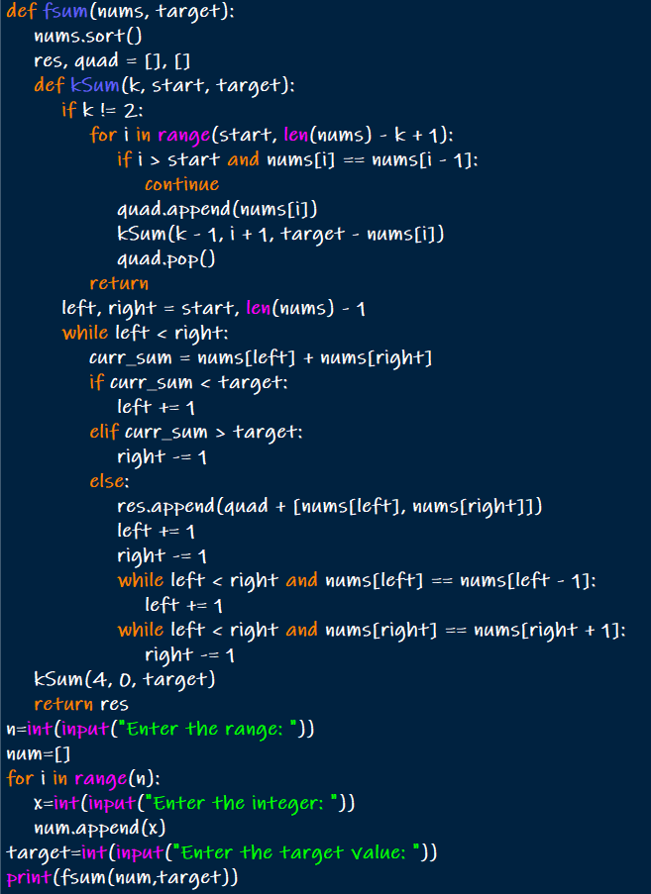

OUTPUT:

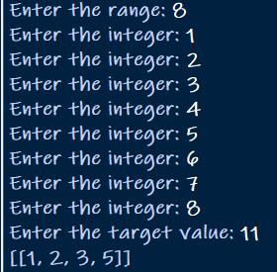

1. Remove Nth Node From End of List

CODE:

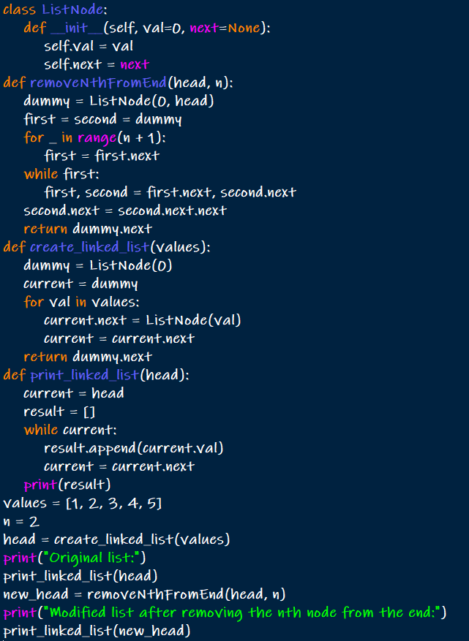

OUTPUT:

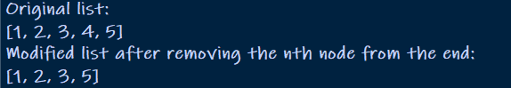

1. Valid Parentheses

CODE:

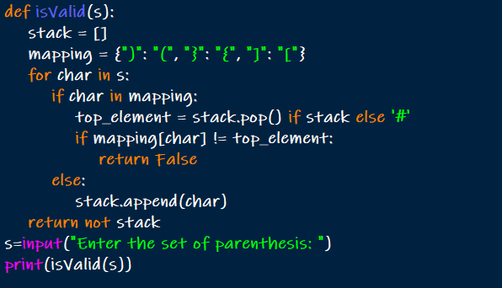

OUTPUT:

